THE UGANDA INTERGOVERNMENTAL FISCAL TRANSFERS (UGIFT)
REPORT ON THE FINDINGS OF HEALTH CENTERS AND SCHOOLS IN PAKWACH DISTRICT – WEST NILE REGION
Date: 4th September, 2026

Preamble
This report details the field monitoring and asset verification exercise conducted for local government educational infrastructure under the Uganda Intergovernmental Fiscal Transfers (UgIFT) program. Recognizing the vital role of transparent asset management in service delivery, this assessment evaluates the procurement, delivery and functionality of assets at Alwi and Wadelai Seed Secondary Schools in Pakwach District. Facilitated by the coordination of the CAO, the DEO, local district finance department, and the schools’ head teachers, this document presents key findings, accountability structures, challenges and technical recommendations to optimize district educational resources

WADELAI SEED SECONDARY SCHOOL PAKWACH DISTRICT LOCAL GOVERNMENT
Executive Summary
This report details the field audit findings and a comprehensive physical asset inventory for Wadelai Seed Secondary School, situated in Wadelai Sub-County, Pakwach District Local Government. Executed under the Uganda Intergovernmental Fiscal Transfers (UgIFT) Programme, this evaluation was conducted in coordination with the Pakwach District Chief Administrative Officer (CAO), District Education Officer (DEO), and the District Finance Department to verify asset procurement compliance, delivery alignment, and current operational functionality.

UgIFT investments at Wadelai Seed Secondary School have established modern academic infrastructure, achieving 100% operational functionality across all 20 desktop computers, server processors, switches, printer, projector, and air conditioners. However, solar panel faults hinder consistent electrical device usage, and a broken plastic water tank stand poses an immediate structural safety hazard to students.
Administratively, the school maintains structured asset logs that accurately capture unit costs. Minor operational repairs are funded internally through school revenue, while major infrastructure challenges are systematically escalated to the DEO. All School Furniture, ICT Infrastructure & Equipment, Science Lab Equipment, Civil Buildings & Sanitation are unengraved.
Findings
- Complete facility construction: 3 classroom blocks (6 classrooms), 1 administration block, 1 multipurpose main hall, 1 science lab block, 1 ICT lab/library block, 3 staff quarters, 3 pit latrines, 4 water tanks, and wire mesh perimeter fencing fully functional.
- Full furniture & lab delivery: 120 desks, 382 student chairs, 74 lab stools, 74 tables, 10 office tables, 10 office chairs, 10 lockers, 15 bookshelves, 8 fire extinguishers, notice boards, 2 gas cylinders, in chemical reagents, and in science lab equipment fully operational.
- 100% functional ICT laboratory: All 20 Dell Vostro computers, server, 2 switches, server UPS, 20 Intex UPS, projector, and 2 Acs are fully functional and in active use.
Qualitative Assessment
An in-depth informant interview was conducted with the Headteacher and administrative staff to evaluate record management, maintenance arrangements, and operational bottlenecks.
Record Keeping
- Detailed asset logging: The facility maintains comprehensive asset logs capturing unit quantities and procurement unit costs.
Repair & Maintenance
- Maintenance escalation: School funds are raised for minor servicing; the District Education Officer (DEO) is notified and supports major repairs.
- Breakdown tracking: Regular functionality records are kept by school management.
Educational Impact
- Academic transformation: The building structures, ICT lab, Library, classrooms, science labs, and staff quarters have created immense room for academic progress in Wadelai Sub-County.
Challenges
- Solar panel defect: Solar panel system faults hinder full usage of electric assets, requiring power grid or solar system restoration. The school has to hire a generator in case there is need to use these assets which is very costly and expensive.
- Water tank collapse hazard: One plastic water tank stand is broken, posing a direct physical hazard to students.
- Office tables with drawers that were supplied lack locks which poses a security threat and a gap in office privacy
Recommendations
- Solar panel overhaul: Dispatch technical solar engineers to repair or replace faulty solar panels and inverters to enable continuous ICT lab operation.
- Grid power extension: Connect the facility to reliable main grid power to support heavy electrical loads.
- Water tank stand reconstruction: Urgently rebuild the broken water tank stand to prevent collapse and student injury.
- Table drawer locks: Retrofit lock barrels onto office table drawers to ensure privacy and security.

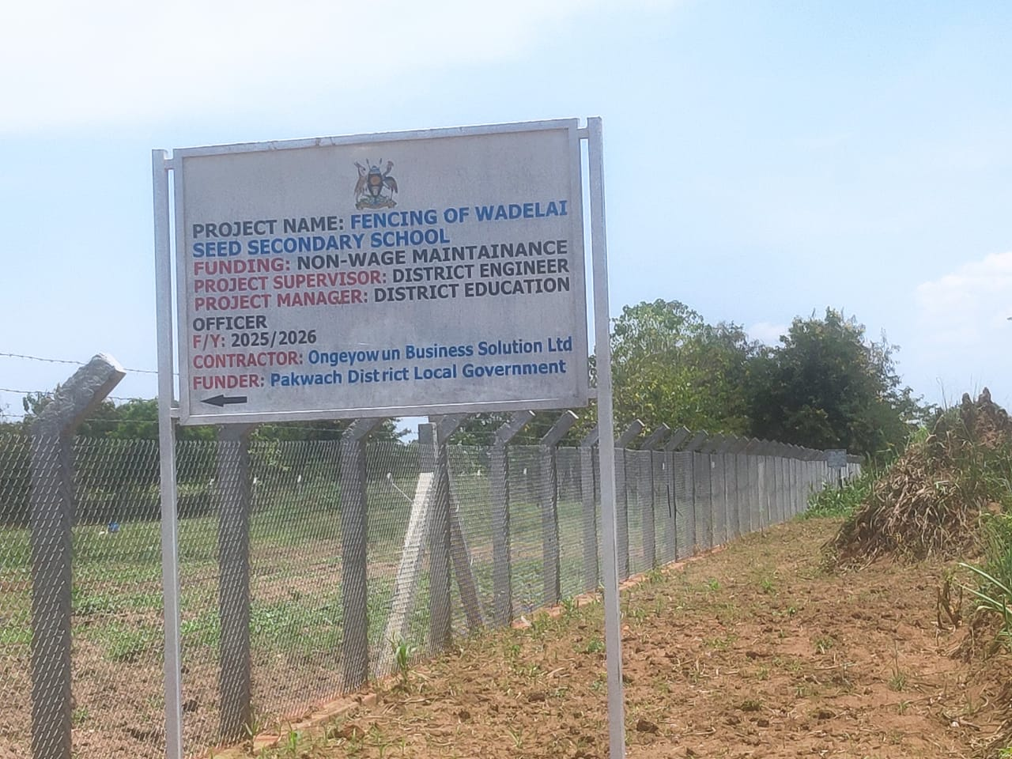
Field Photos
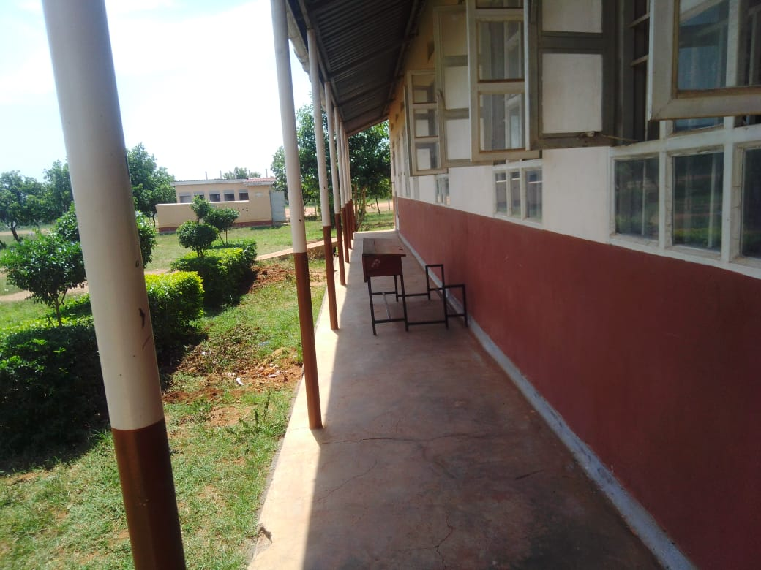

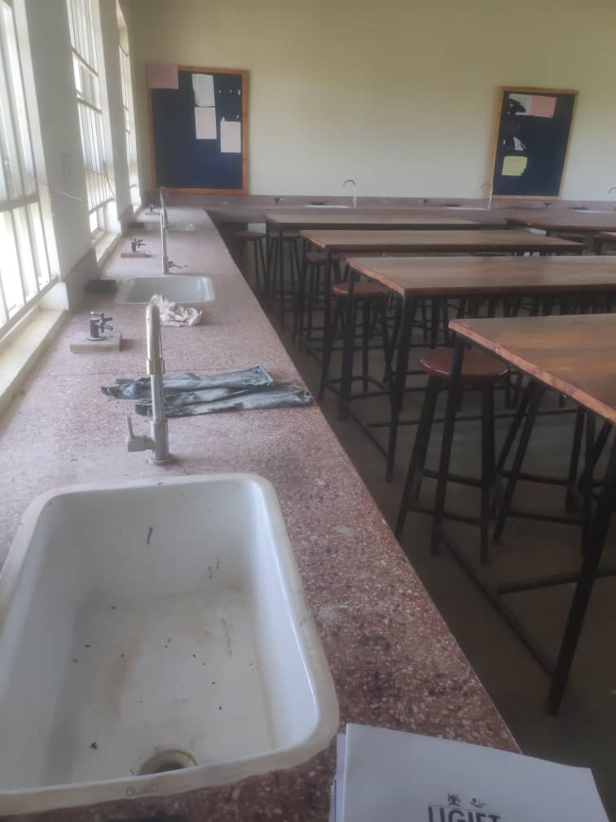

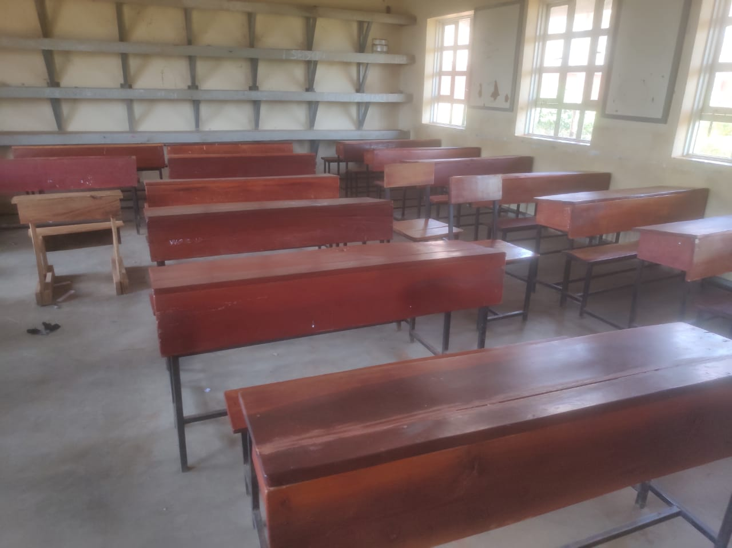

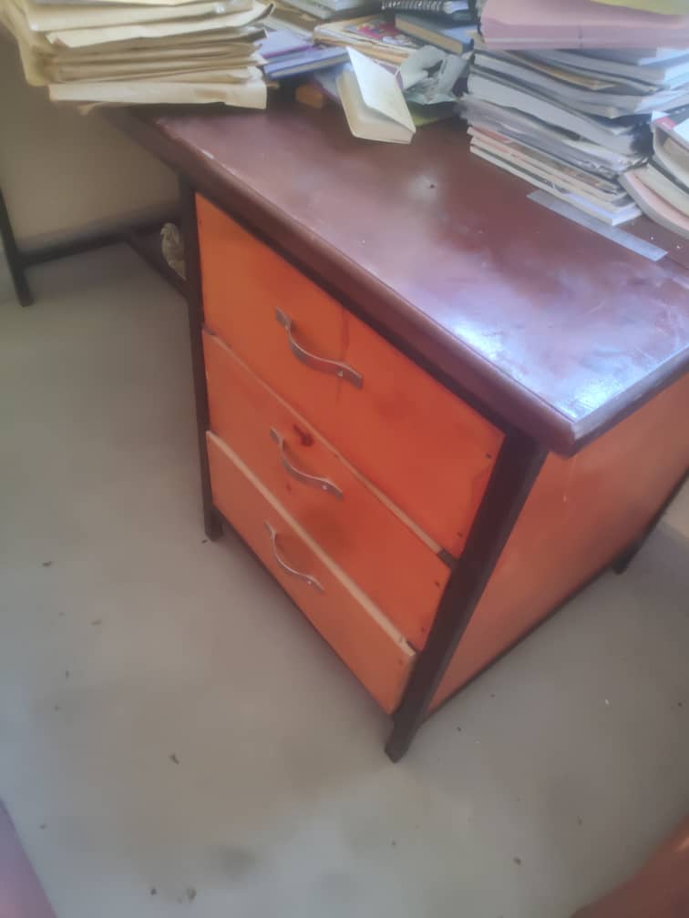

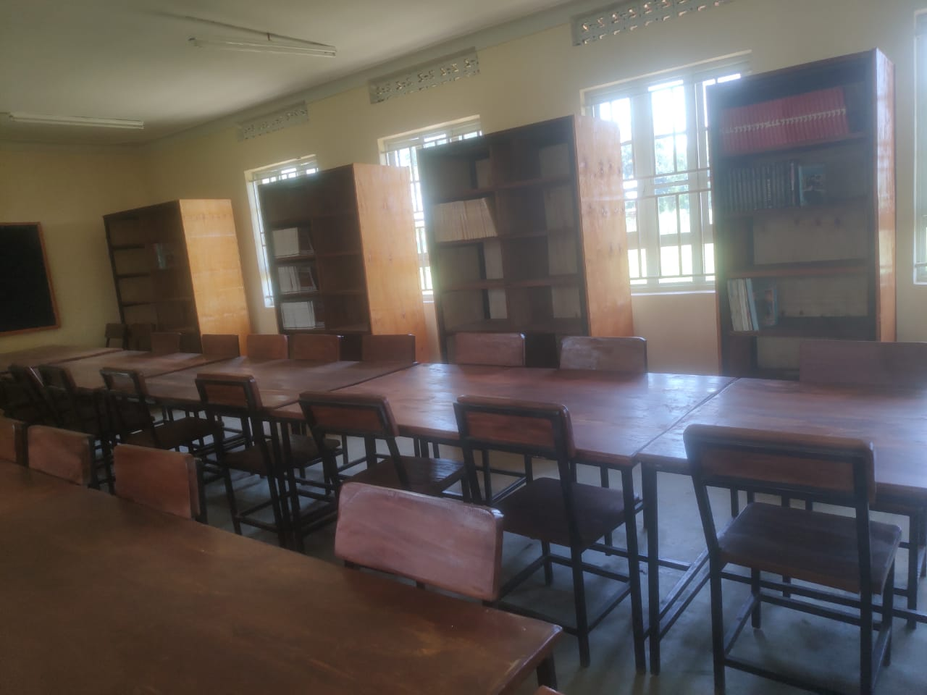
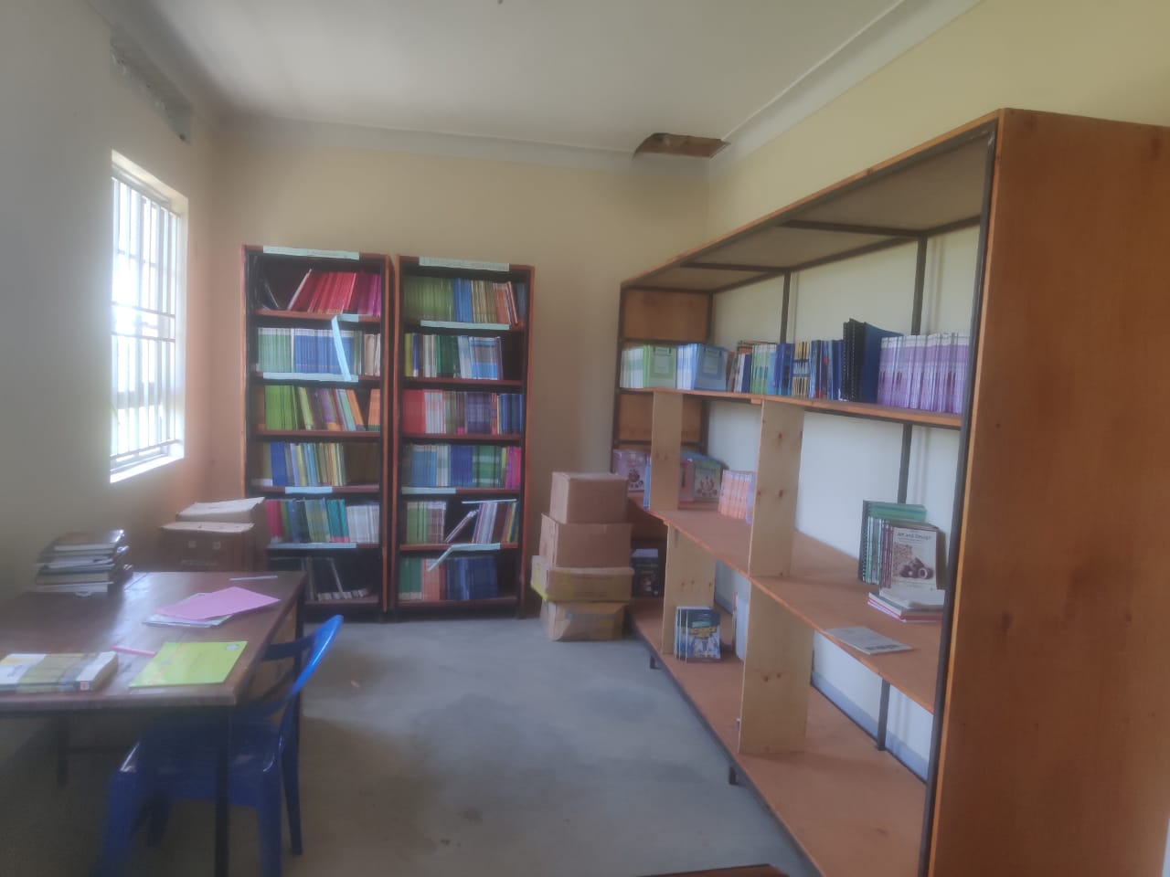

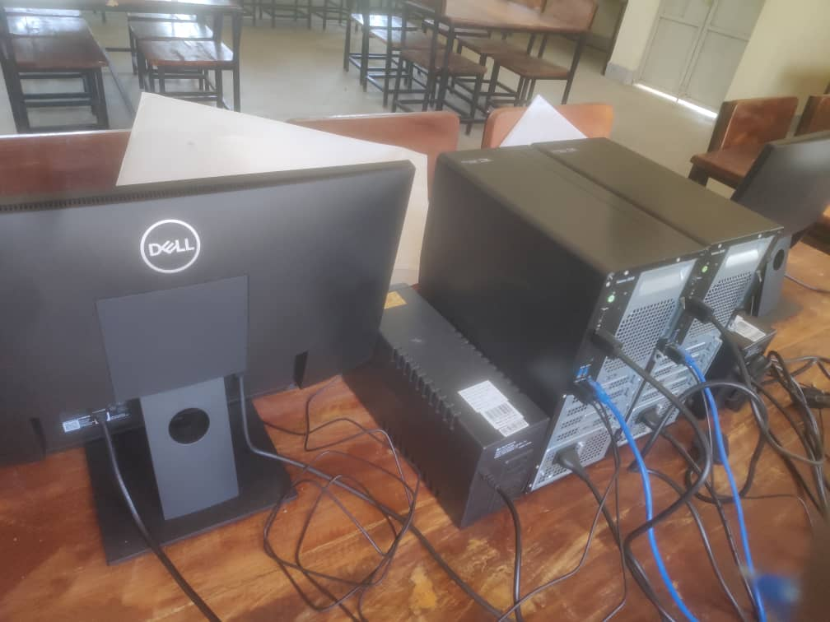
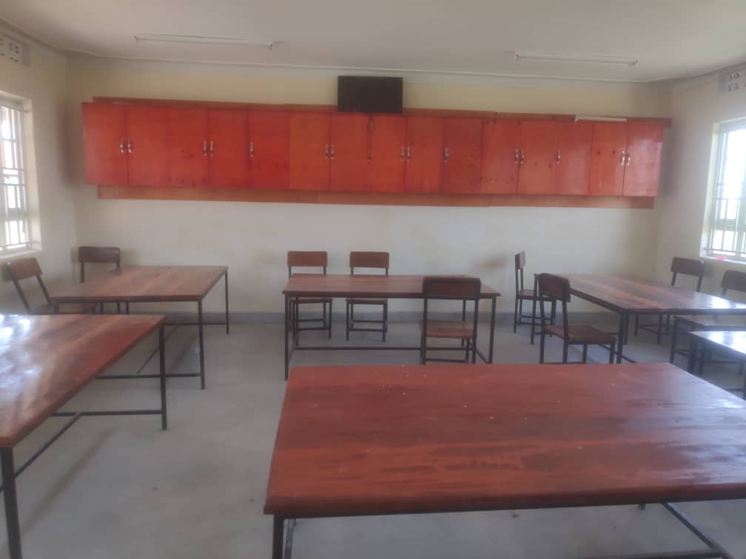

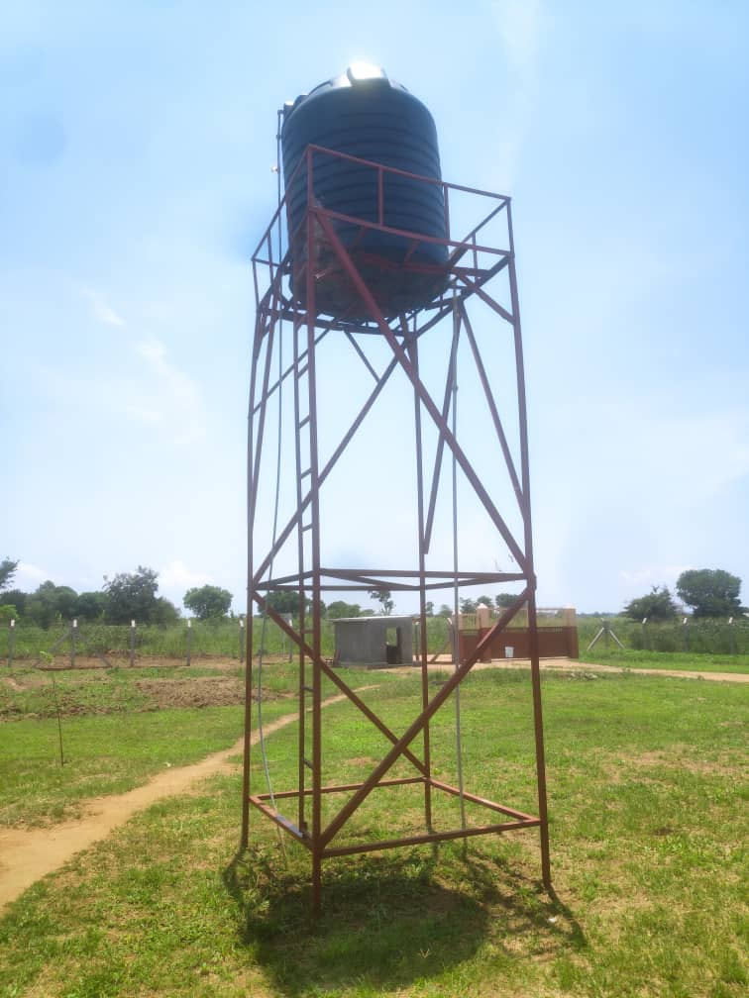
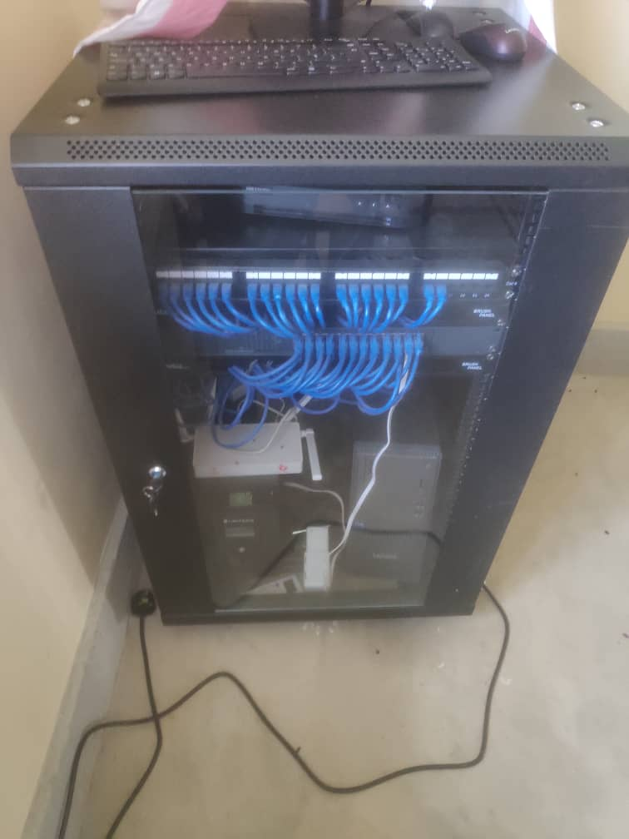

ALWI SEED SECONDARY SCHOOL PAKWACH DISTRICT LOCAL GOVERNMENT
Executive Summary
This report presents the field audit findings and comprehensive physical asset inventory for Alwi Seed Secondary School, located in Alwi Sub-County, Pakwach District Local Government, executed under the Uganda Intergovernmental Fiscal Transfers (UgIFT) Programme.
UgIFT investments have completely revolutionized secondary education delivery at Alwi Seed Secondary School. However, critical operational risks persist: severe electrical power surges have caused catastrophic ICT hardware failures—destroying 9 display monitors, 10 system units, 21 UPS units, and 12 CCTV cameras. Furthermore, a broken plastic water tank stand poses a direct collapse hazard to students, and severe understaffing strains operations for an enrollment exceeding 1,000 students.
Maintains complete asset logs; repairs funded internally from school revenue. Partial ICT tagging ('ALWI SEED S.S'); all furniture, science assets, and civil structures are unengraved.
Key Audit Observations & Highlights
- Infrastructure modernization: 3 classroom blocks (6 classrooms), 1 administration block, 1 multipurpose hall, 1 science lab block, 1 ICT lab & library block, 3 staff quarters, 3 pit latrines, 4 water tanks, and perimeter wire mesh fencing delivered and fully functional.
- Complete furniture allocation: 120 desks, 382 student chairs, 74 lab stools, 74 tables, 10 office tables, 10 office chairs, 10 locker cabinets, 15 bookshelves, 8 fire extinguishers, notice boards, and 2 gas cylinders delivered and in active use.
- Science lab provision: Chemical reagents and science lab equipment fully delivered and functional.
- Heavy power surge ICT damage: Power surges destroyed 9 monitors, 10 CPUs, 21 UPS units (20 Intex UPS + 1 Server UPS), and 12 CCTV cameras.
Qualitative Assessment
An in-depth informant interview was conducted with the Headteacher and administrative staff to evaluate record management, maintenance arrangements, and operational bottlenecks.
Record Keeping
- Asset record management: The school maintains complete records of all assets provided under the UgIFT program.
Repair & Maintenance
- Internal maintenance funding: The facility raises internal operational funds to service and repair minor equipment.
- Functional breakdown logging: The school keeps regular records of asset functionality and equipment breakdowns.
Educational Impact
- Revolutionized education delivery: Modern infrastructure and laboratories have dramatically elevated teaching quality and academic performance in Alwi Sub-County.
Challenges
- Power surge vulnerability: Unstable electrical grid current and frequent surges have severely damaged ICT lab equipment. Additionally, the school has to hire a generator in case there is need to use these assets which is very costly and expensive.
- Severe enrollment pressure: Student enrollment has surpassed 1,000 students, creating high student-to-teacher, classroom, and latrine ratios.
Recommendations
- Power surge protection: Install industrial-grade Automatic Voltage Regulators (AVR) and heavy-duty surge suppressors to isolate ICT hardware from power spikes.
- Solar system backup: Upgrade the ICT block solar system to provide clean, stable backup power for computer lab operations.
- ICT hardware repair / replacement: Re-equip the ICT lab by repairing or replacing the 9 damaged monitors, 10 system units, 21 UPS units, and 12 defective CCTV cameras.
- Teacher & support staff recruitment: MoES and Pakwach DLG should recruit additional teachers to relieve severe staffing ratios for >1,000 students.
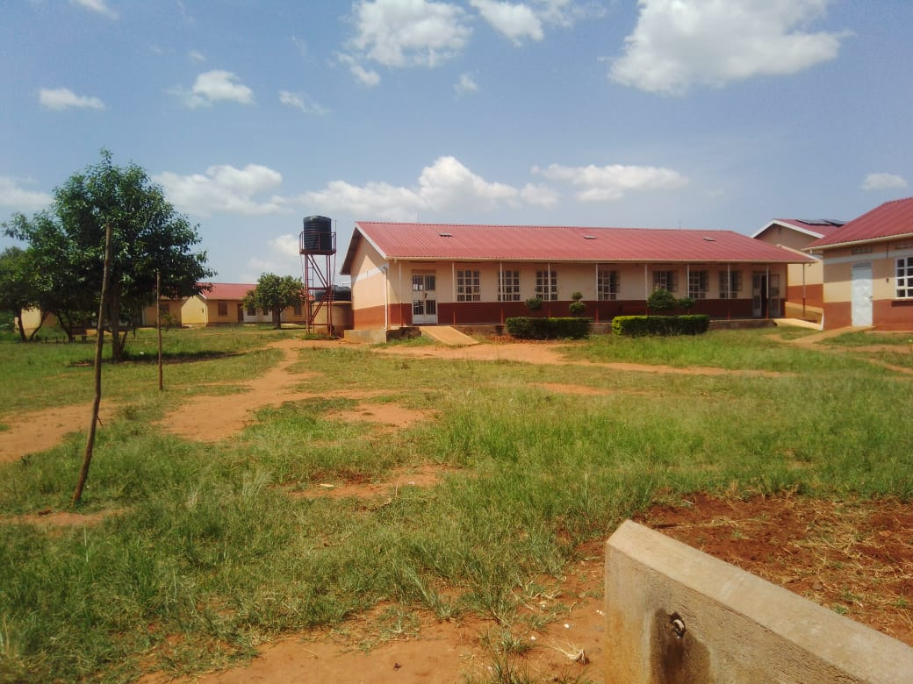
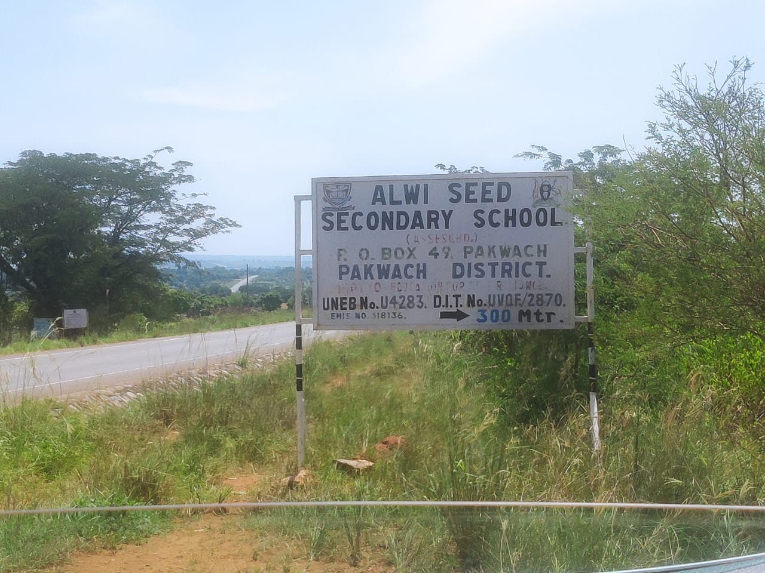
Field Photos

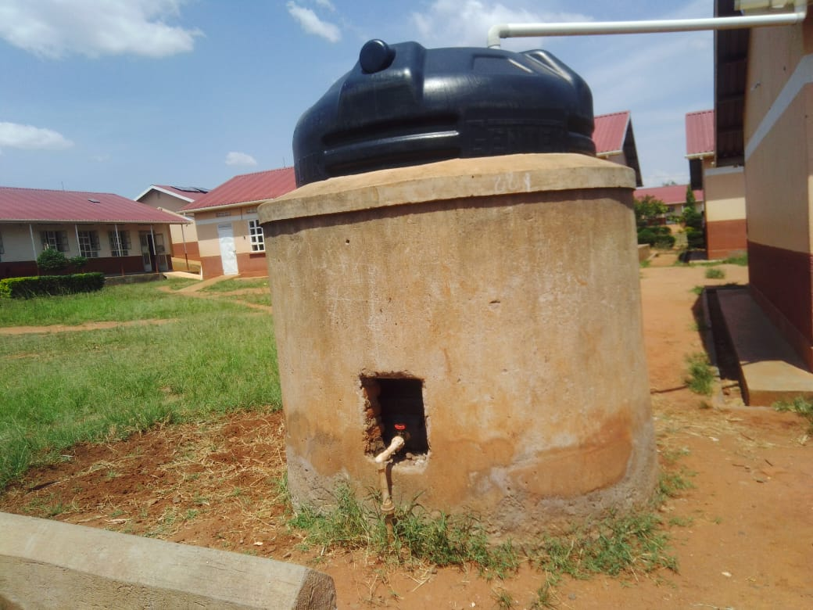
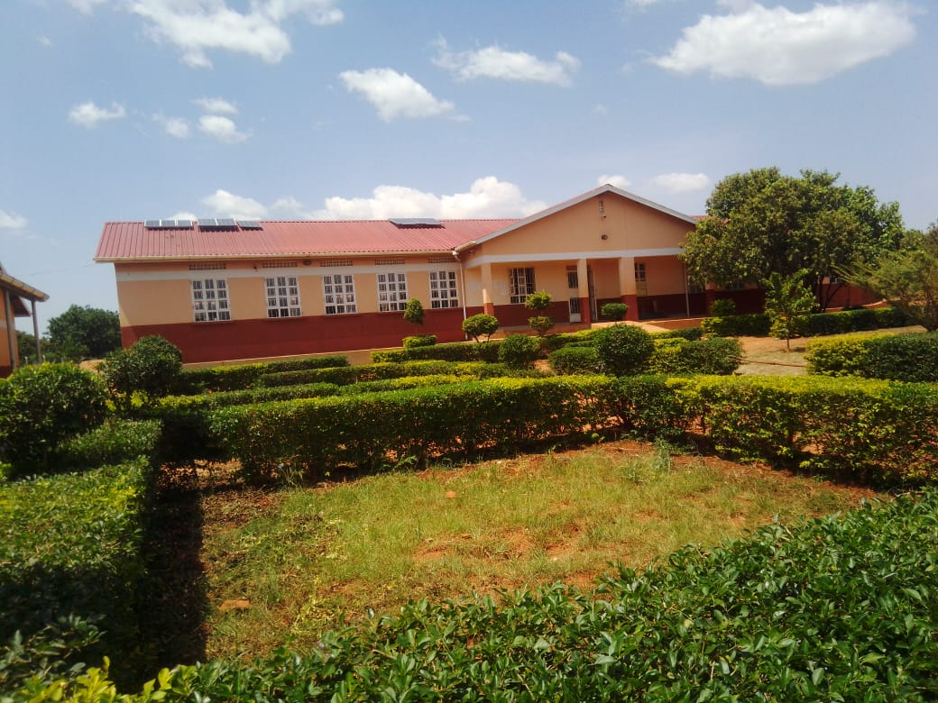

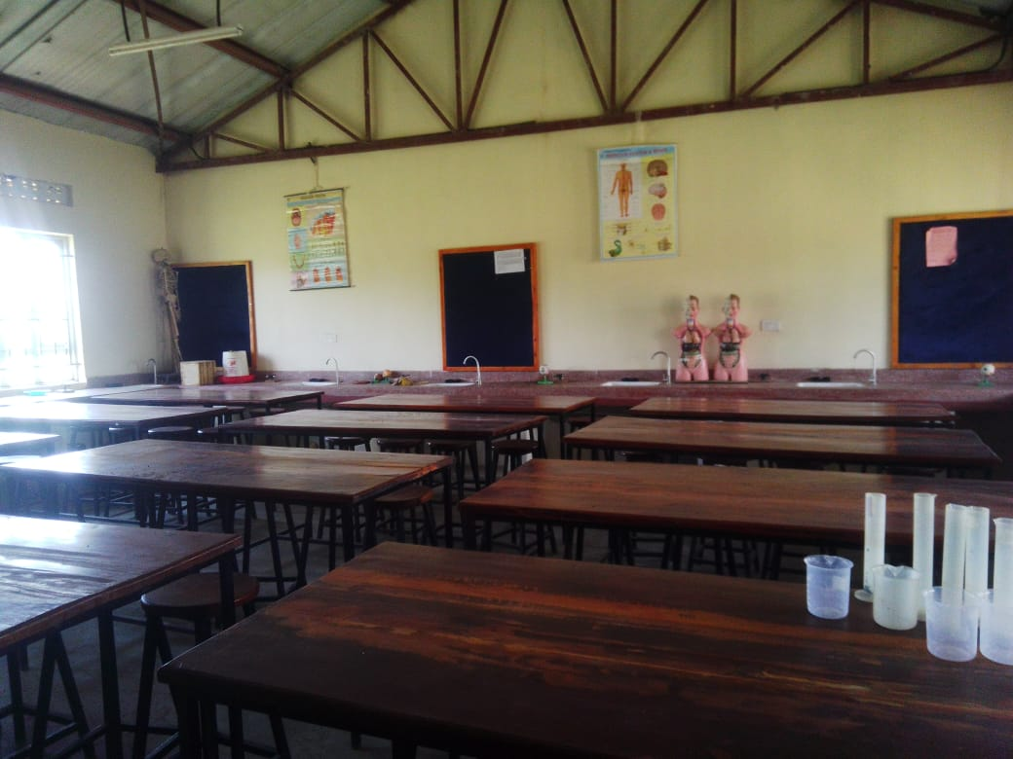
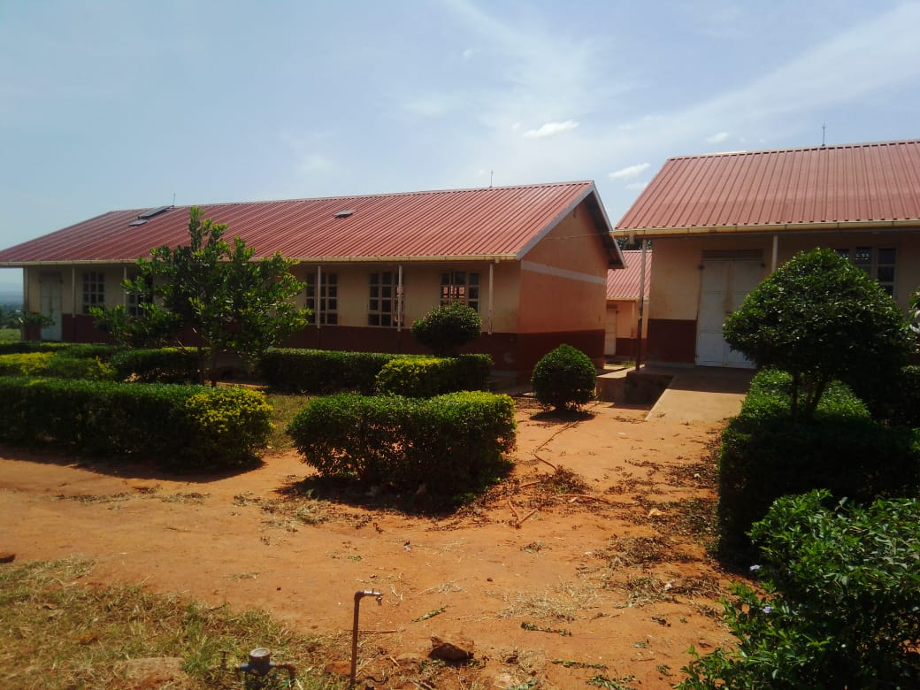

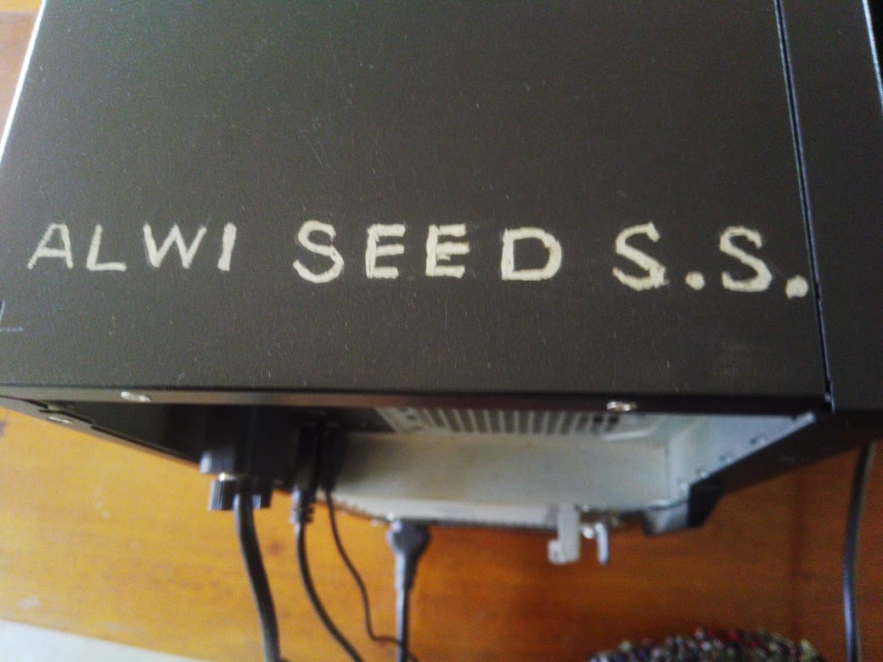
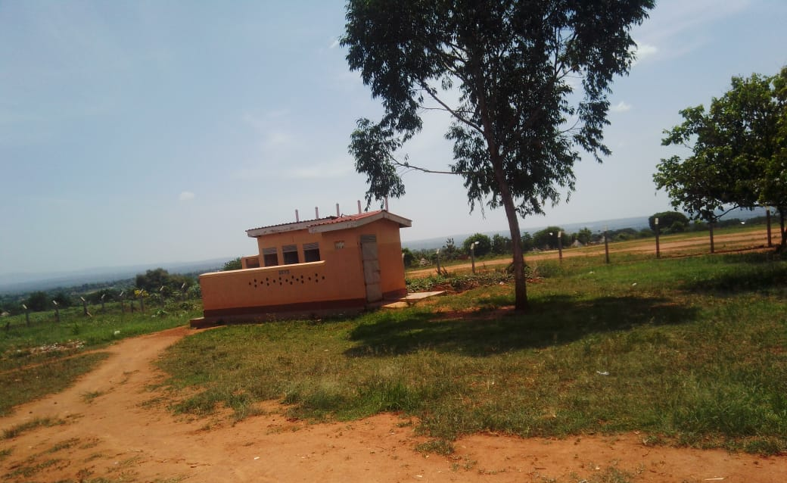

Report compiled by:
Isah Lukwago and Stella Male

